Contractual Payroll Quick Start Guide.

Features:

1. User Authentication and Access Rights
2. Minimum User Intervention required.
3. Fully Linked with Attendance System.
4. Dynamic Pay Cycle with dynamic reports.
5. Default Calculation Parameters.
6. Setting Up Database Connection.

Menu Path: Admin->Database Connection

Used to for Configuration of existing Attendance System Database.

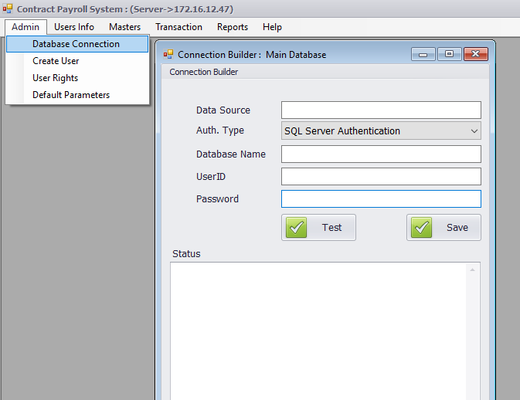

1. Create Application User:

Menu Path: Admin->Create User.

Used for Application user creation and configure User Rights.

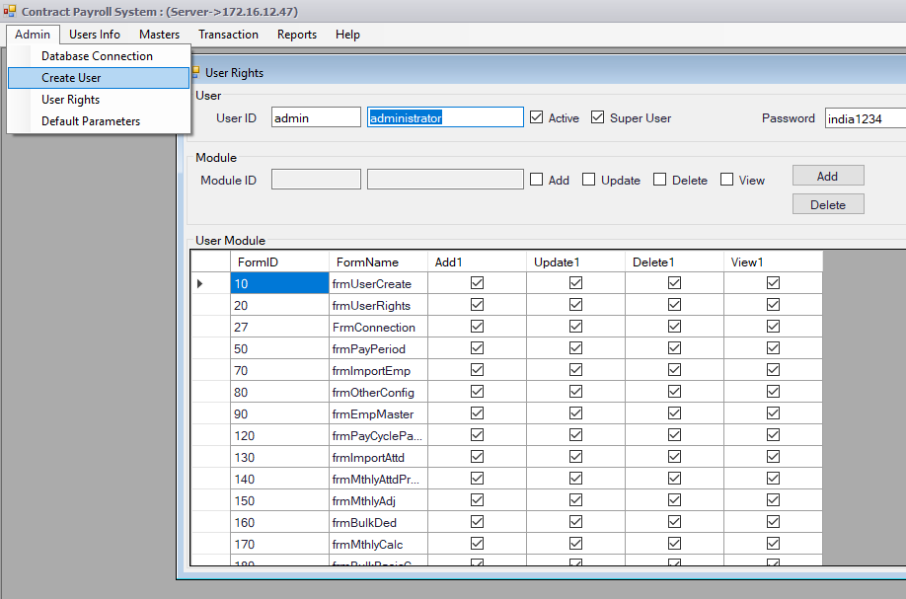

1. Setup Default Parameters.

Menu Path: Admin->Default Parameters

Used for configure required tax slabs/ contract man power supplier’s rate and taxes, PF deduction rates and other kind of deduction like (LWF, ESI…etc.)

One Time Configuration.

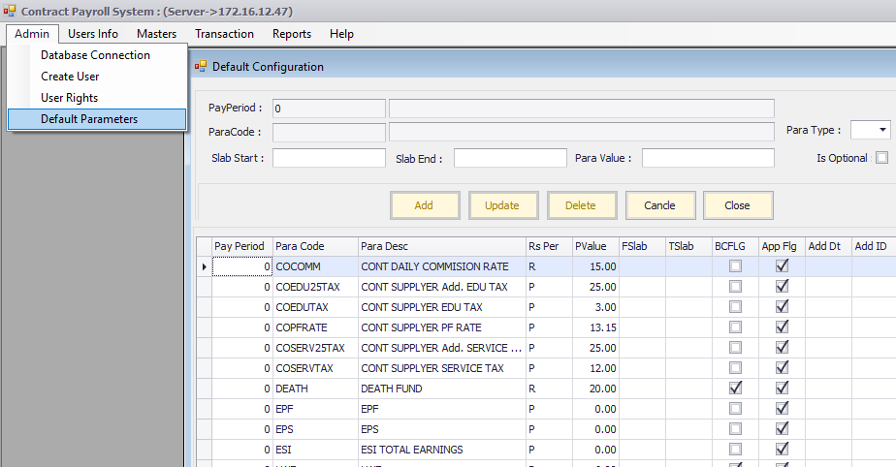

1. Create Pay Cycle

Menu Path: Master->Pay Cycle

Used for define wages calculation period from date and to date. All the rest of calculation based on this pay cycle.

Example: Wages calculation for the month of Jan 2018.

Create new pay cycle if not already defined.

Pay Period ID is: auto incremented.

From Date: 01-01-2018

To Date: 31-01-2018

And press Add Button.

This is will open a new period in system, and further task will be associated with this pay cycle.

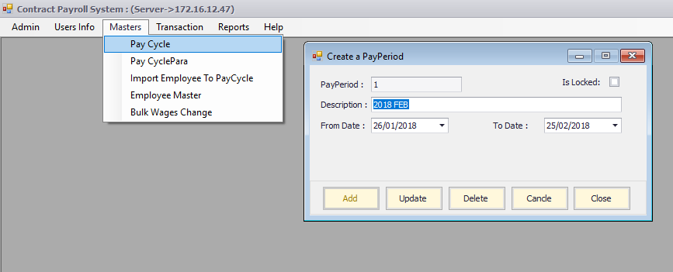

1. Pay Cycle Parameters

Menu Path: Masters->Pay Cycle Para

Used for change in default parameters, which was configured in default parameters if required.

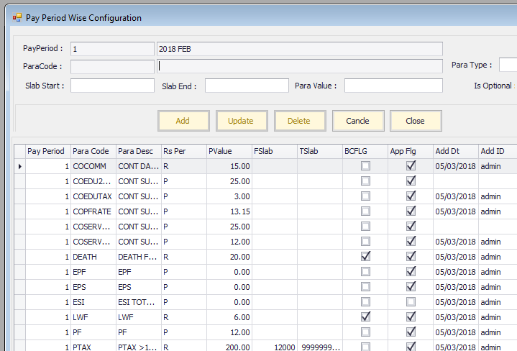

1. Import Employees in Newly created pay cycle.

Menu Path: Masters->Import Employee to Pay Cycle.

This used for Link Employee with Pay Cycle, all active employee of (CONT/JOBWORK)-WrkGrp with defined wages and costcenter, will be imported in contractual Software.

There are two parameters

EmpUnqID : only import supplied employee

ContCode : import all employee of supplied contractual code.

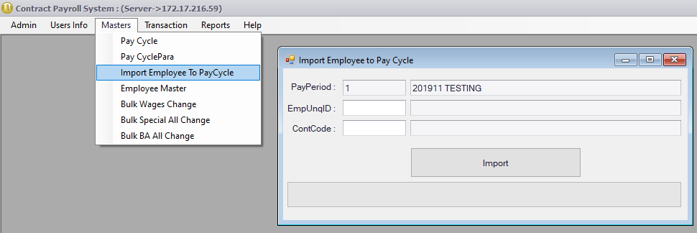

There are Main two requirement for import employees,

1. Employee must be defined wages in attendance system, zero amount will not be considered.
2. CostCode also need to configured in attendance system. To configure employee costcode in attendance system, use highlighted menu for individual employee or use the “Bulk Update Employee CostCode” for multiple costcode upload using excel template.

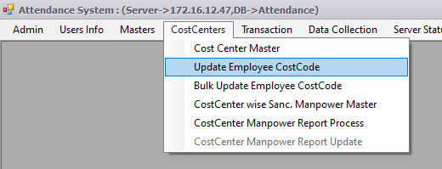

1. Employee Master Data

Menu Path: Masters->Employee Master.

This is used for view details of employee imported in earlier step (step-5), which contains three tab

1. Employee Details
2. Wages Details
3. Attendance of employee during the pay cycle. (will show after the import of Attendance step).

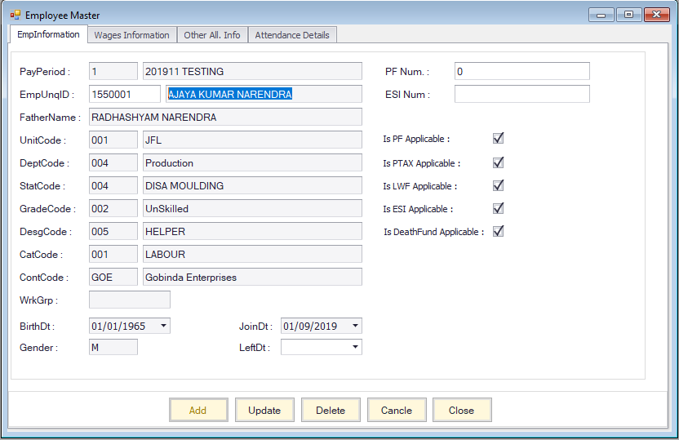

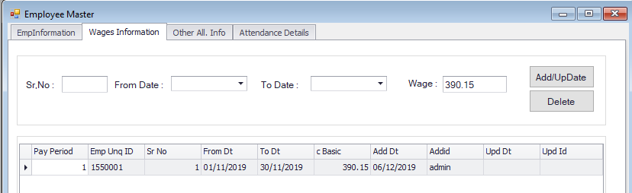

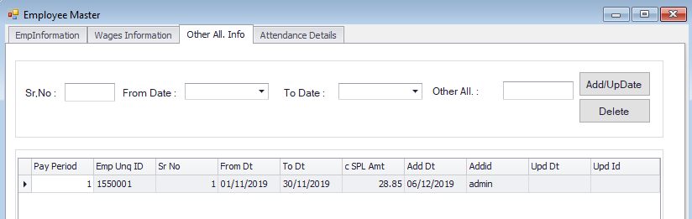

Incase of any need/requirement to change the wages, select the row from grid and double click on row, record appears in change mode, you can change the amount/rate and press the update button. New rate will be applicable for the current pay cycle.

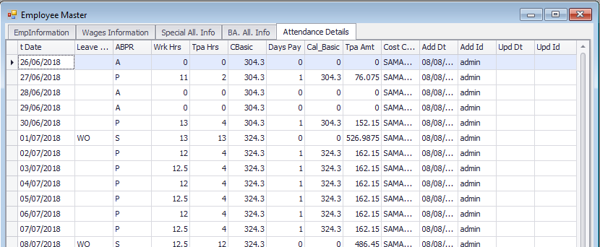

After the Importing of employees, software has provision for bulk wages changes scenario for all type of wages if required using excel templates.

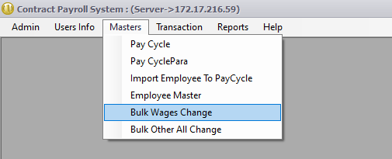

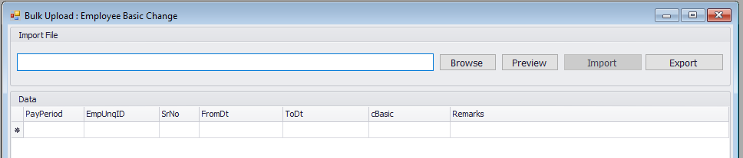

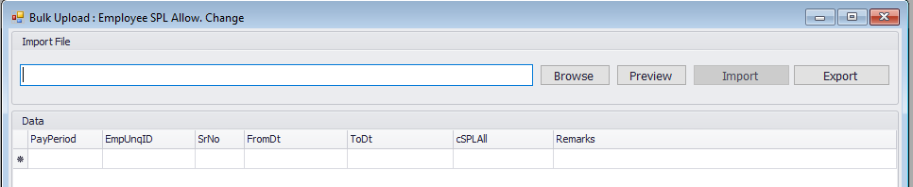

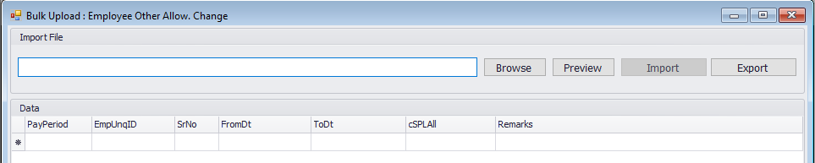

1. Import Employee Attendance.

Menu Path: Transaction->Import Daily Attendance.

Used for import employee attendance in configured pay cycle.

If EmpUnqID provided system will import attendance of provided EmpUnqID.

If ContCode Provided system will import attendance of provided Contractor.

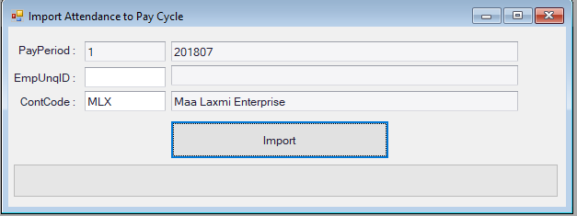

1. Monthly Adjustments.

Menu Path: Transaction->Monthly Adjustments

Used for any adjustment of dayspay, good work, other deductions for employee if required.

Contains Two Tabs:

1. Monthly Adjustment
2. Other Deduction (Mess/Advance/Other Deduction etc..), use the F1 Key in DedCode Field for selection.
3. Also we have provided bulk upload of deduction for Mess/Advance/Other Deduction.

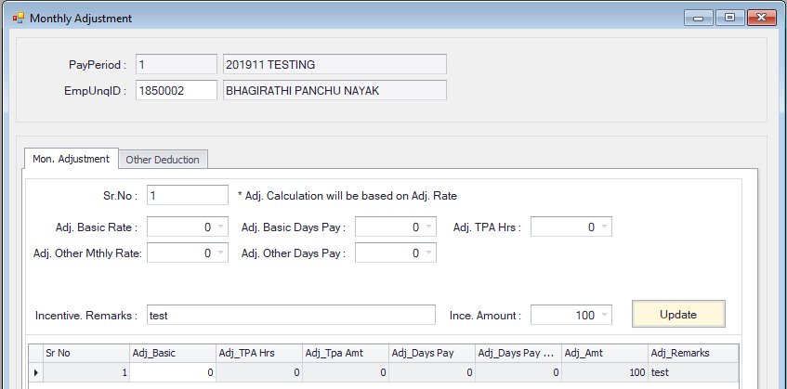

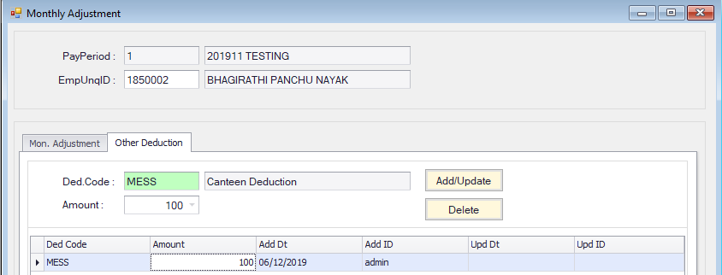

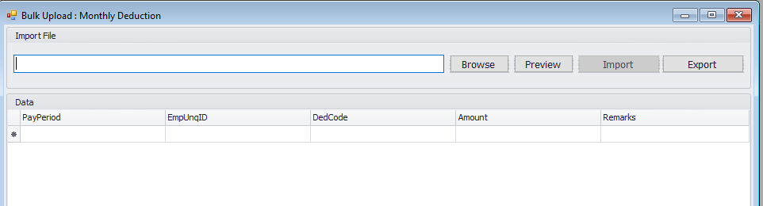

1. Monthly Attendance Process.

Menu Path: Transaction->Monthly Attendance Process

Used for internal wages calculation.

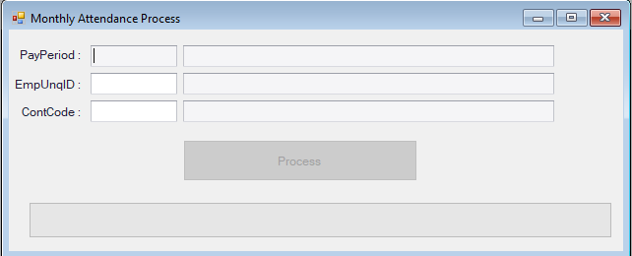

1. Salary Calculation

Menu Path: Transaction->Salary Calculation.

Used for wages calculation.

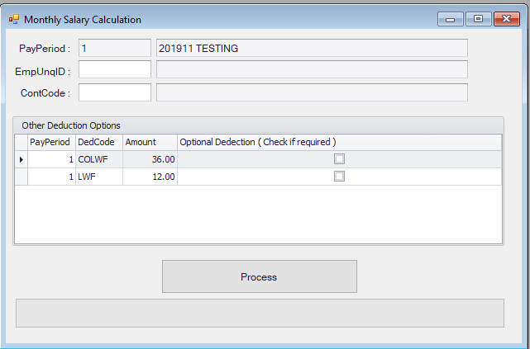

1. Reports: Reports are dynamic and available for excel export options. Using Reports Menu.

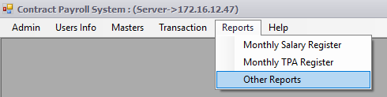

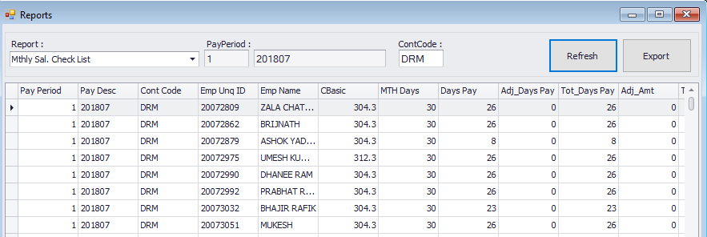

After Everything is finalized you have to lock the period, so no alteration can be made in system. Using IS Locked with check mark and update the record. This Action will ensure the data protection. Once pay cycle is locked system will not allow further transaction.

Do not unlock the pay cycle for data security.

